Procedural Methods
Tutorial 5: Basic Collision Detection

Why this is important

Collision detection is used in many areas, for gameplay, and aesthetics so it’s important to know some basic techniques and know where to find about advanced ones.

What you need to know
Here we will cover some collision techniques that can provide simple effective collision detection for a variety of situations in 2D or 3D games.

Firstly a definition: We are discussion collision DETECTION here. This is a separate process from collision resolution. So we are only detecting when object collision or intersection has taken place the responding change in motions, behaviours of existence of effected objects is dependent on the context of the game and up to you to determine.

The technique we are investigating is an “AABB” or “axis aligned bounding box”. This allows us to check for collisions between any rectangular shapes in two dimensions. But by definition these shapes cannot be rotated (Remember, AXIS aligned) Once we achieve this we will have an effective 2D Collision detection system.

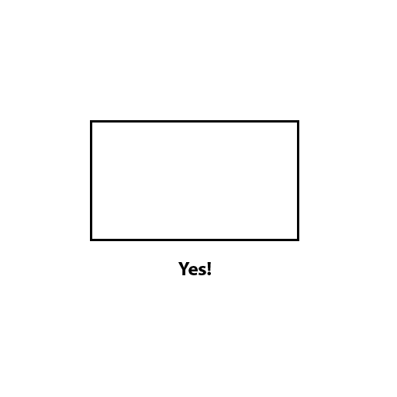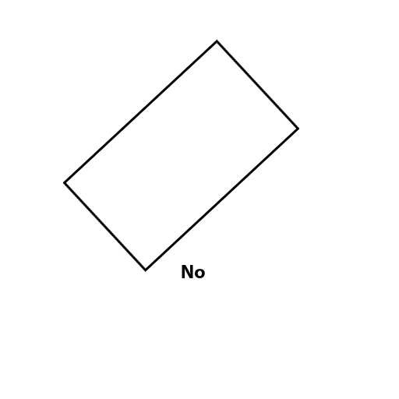

But what use is 2D collision for a 3D game? Well in the example of our rogue dungeon example we can use a 2D AABB system to handle player collision with all walls pickups, monsters and any other game objects. A lot of functionality from a simple system.

Before we move on though, a note on FLOOR collision. This is typically achieved by limitation. We can check the player height has not moved beyond a certain value and restrict them to always be on the floor level.

Ie. If y > limit
y = limit

This makes sure the players y value cant progress through this limit no matter how much the player attempts to do so. But onto AABB.

So we have two objects rectangular objects.

How can we test if they overlap??
For each collidable object we need to know some information its position (Generally considered as the centre point of the object) and its width and height.

Thinking through this problem logically you may reach the conclusion that it would be logical to create a series of tests to see if the sides of the object are within the sides of the other object using the positions width and height and then calculate

Is the top of object B between the top of object A?
Is the left of object B between the left and right of object B? etc etc

This can quickly get confusing and luckily there is a much simpler method known as “Separating axis theorem” or SAT

Separating Axis Theorem

The basic theory is : its easier and quicker to check if the objects do NOT overlap. Than to verify they do. If there is any non-overlap in any axis. The objects do not collide and there is no need to run further tests.

Ie

Check for object B top edge separation with object A
Check for object B bottom edge separation with object A
Check for object B left edge separation with object A
Check for object B right edge separation with object A

If there is a separation in ANY of these, there is no collision. So if any fail we can bail out and move onto the next object!

When you are writing your own collision routines remember to take account of widths and heights and START SIMPLE! Do not jump right in to having multiple objects!

Note:
You Can use AABB to keep objects inside others! So if you want to keep the player (rectangular collision) inside a rectangular room AABB is the way to do it just make sure the player never Un-intersects the room.

In a series of connected rooms you will have to use a set of conditions to allow passage through corridors into other rooms but that’s up to you to determine.

Tasks:

Task 1:

Implement a simple AABB collision check between two rectangular objects using the separating axis method described above. I would use a couple of rectangular pieces of geometry viewed from a fixed camera angle (above) just so you can see what’s going on.

Task 2:

Once you have this working can you RESTRICT an object within another larger boundary object? Give it a try.

Task 3:

Multiple collisions. If we have a constrained object within a larger object. Can you have multiple objects? A simple effective test is to replicate your small object and give it an autonomous movement. If it hits the sides simply have it reverse its direction depending on what side it hit. You then have a bouncing trapped object.

And then what if you want to have the multiple objects also collide with each other as well as the boundary? :D

The more collision objects you have, the more checks you need to do because every object needs to check against every other object. So beware of explosive growth! In games there are further techniques, which allow you to manage and make sure collisions are not checked unnecessarily.

If you want to push yourself, further:

These are two excellent tutorials on collision detection in 2D and 3D and cover everything we discussed here in MUCH more depth and detail with further techniques, the ability to handle more complex shapes and more!

http://www.metanetsoftware.com/technique/tutorialA.html

http://www.metanetsoftware.com/technique/tutorialB.html

